# Top 5 Fashion and Comfort Clothes for this summer season

Summer 2025 fashion is all about bold colours, airy fabrics, and relaxed oversized fits for ultimate comfort. Retro ’90s and Y2K styles make a comeback with a modern twist. Sustainable and tech-enhanced textiles add both style and function to your wardrobe.

Click here to know more : <https://dikefashions.com/2025/04/30/top-5-fashion-and-comfort-clothes-for-this-summer-season/>

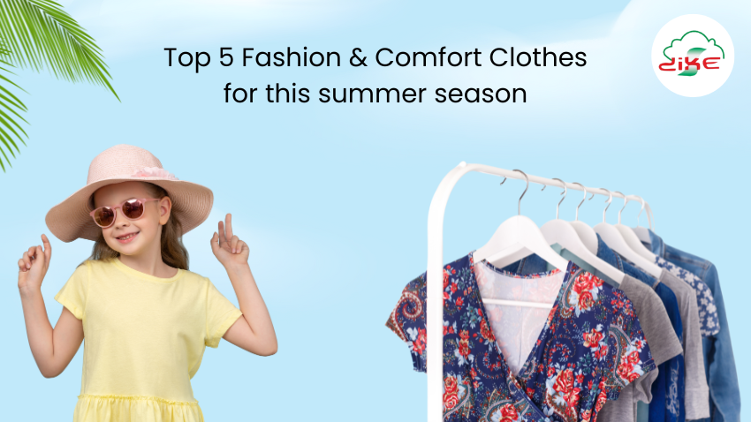

#90sFashion #ComfortableYetStylishOutfits #CottonComfort #DikeFashion2025 #DikeFashionOnline #DikeFashions  
#EcoFriendlyFashion #ExpressYourStyle #FashionAndComfortClothes #OversizedStyle #Retro90sSummerFashion #RetroRevival #StylishAndSustainable #Summer2025Fashion #Summer2025StyleTrends  
#SummerStyle #SummerWardrobe #SustainableSummerFashion2025  
#TechEnhancedTextiles #UVProtectionClothingTrends #WardrobeGoals

#BabiesSleepsuit #ZipperSleepsuit #BlackFullSleeveTshirt  
#CushionCovers #HomeDecorStyle #BoysFullSleeveTshirt #GirlsLeggings  
#KidsFashion #GreyMensHoodie #MensCasualWear #LadiesBrief  
#WomensInnerwear #LadiesPrintTshirt #WomensCasualStyle  
#StylishShocks #ComfortWear #EverydayEssentials  
#TrendyBasics #FamilyFashion  
#WardrobeEssentials